Gun Type Anti Drone Device

Model No: TTSKP08
- Dear users
Thank you for using this anti drone device. Please read the manual for this product carefully before using it. We have taken great care in preparing this manual and believe that the information provided in it is correct and reliable, however, there are inevitably errors and omissions and we would appreciate your understanding and correction.
This product is suitable for places where drones are forbidden to fly!
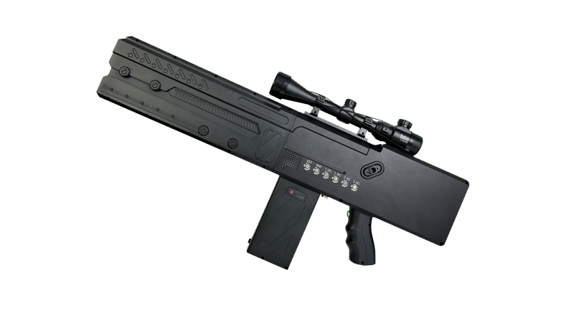

- Caution
- Check the battery level before using the device and charge it if it is below 40%.
- The device should avoid large objects as far as possible to ensure the jamming effect.
- When using outdoors, you should pay attention to the waterproof effect and also avoid exposure to the sun.
- The best results are achieved by pointing the direction of the drone when using it.

- Package List
- Product main unit*1
- Charging power*1
- Battery*1
- Airline case*1
- Carrying strap*1

- Product show
One battery on standard,can custom two batteries.
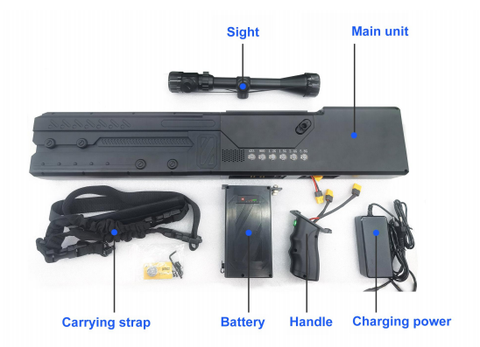
- Product parameters
Name | Anti drone gun | Custom | Support
Channel | 410MHZ-460MHZ  824MHZ-960MHZ  1100MHZ-1300MHZ  1550MHZ-1650MHZ  2400MHZ-2500MHZ  5700MHZ-5900MHZ | Function | forced landing, return to flight,  cut off video.
Distance | 1000-2000 M | Output power | 180W
Weight | 6.0KG | Size | 710*290*70（mm）
Voltage | 220V to DC 29.4V | Power supply | Built-in battery24V  （5AH）
Directional  Antenna | Vertical 45° Horizontal45° | Temperature | -20℃ / +45℃

- Instruction
- Before using the product, please install the antenna first.
- Forced landing of DJI class drones; on; 1.5G, 2.4G, 5.8G;Drive off DJI class drone; turn on; 2.4G, 5.8G.
- Forced landing of Dowcom class drones; on; 900mhz, 1.5G, 2.4G, 5.8G.Drive off drones of the DOT class; on; 900mhz, 2.4G, 5.8G.
- 400mhz is the remote control band for homemade class drones, as well as our common TV remote control, car keys, children's toys class, etc.
- 900mhz is the common remote control band for industrial grade drones, as well as our common police grade, custom-made drones,large class drones, etc.
- 1.2G is China's self-developed BeiDou navigation system, the future will also be used in the drone industry, as the second positioning system of 1.5G (GPS), the future will be used

Note: Whether the device is used or not, please charge the device once every half month to ensure the performance of the battery.

- Demo diagram
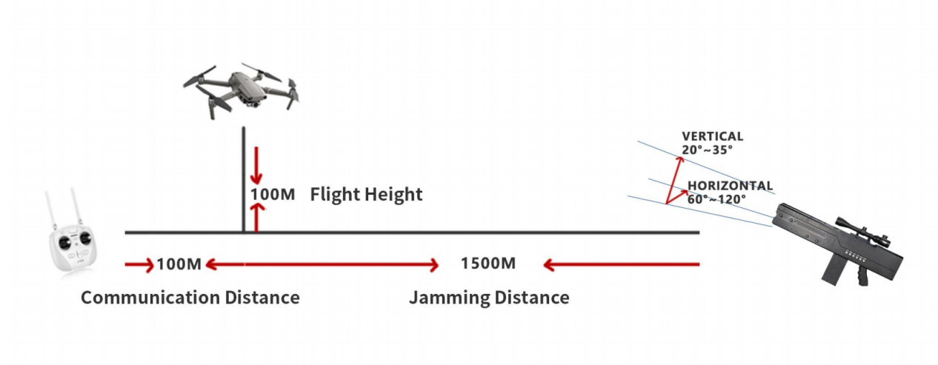
- Data analysis
According to the testing standards of the Ministry of Public Security, the distance between the drone and the remote control is 100 metres and the jamming distance is around 1000 metres.the anti drone device is used to destroy the drone reception conditions and cut off the communication between the drone and the remote control by generating an interference signal with the same frequency as the drone reception to achieve the jamming effect.The shielding radius in unobstructed space is determined by both the path attenuation and the level of the control remote control
transmission signal.

The table below gives a comparison of distance and path attenuation. The radius of coverage can be determined by the output channel power of the jammer, the remote
control signal level and the gain of the coverage line. As following equation:

Pch+Gat-L-FAF≥Prx

Pch : | Output channel power minimum
Gat : | Antenna gain
L : | Path attenuation
FAF : | Additional value of path loss，range 6-8dB
Prx : | Received signal strength

Distance VS. Attenuation table

L=32+ 20logd +20logf+ FAF f(MHz) d (km)

Distance（Km） | 900MHz  Loss（dB） | 1575MHz  Loss（dB） | Distance（Km） | MHz  Loss（dB） | 900MHz  Loss（dB）
1 | 38 | 44 | 25 | 66 | 72
2 | 44 | 50 | 30 | 67.5 | 73.5
3 | 48 | 54 | 35 | 69 | 75
4 | 50 | 56 | 40 | 70 | 76
5 | 52 | 58 | 45 | 71 | 77
6 | 53.5 | 59.5 | 50 | 72 | 78
7 | 55 | 61 | 60 | 73.5 | 79.5
8 | 56 | 62 | 70 | 75 | 81
9 | 57 | 63 | 80 | 76 | 82
10 | 58 | 64 | 90 | 77 | 83
15 | 61.5 | 67.5 | 100 | 78 | 84
20 | 64 | 70 | 200 | 84 | 90

